**Index.html**

**Source code:-**

<html>

<head>

<link rel="stylesheet" type="text/css" href="style2.css">

</head>

<body>

<header>

<div class="main">

<div class="logo">

<h1>TRAVEL <br> and <br>LEISURE</h1>

</div>

<ul>

<li class="active"><a href="#">Home</a></li>

<li><a href="#about-us">About</a></li>

<li><a href="#Contact-us">Contact-us</a></li>

<li><a href="#Our_services">Services</a></li>

<li><a href="registration.html">Login</a></li>

</ul>

</div>

<div class="title">

<h2>The traveler sees what he sees<br>the tourist sees what he has<br>come to see.</h2>

<div class="single"></div>

<h1>Explore The Colorful World</h1>

</div>

</header>

<section class="home-packages">

<div class="hos">

<h1>Upcoming destination</h1>

<div class="line"></div>

<p>Plan your Indian holiday with our collection of personalized

India tour packages. Explore our collection of travel destinations,

or just select your holiday style. We also offer city breaks, staycations,

destination weddings, and private charters in selected destinations across India.

</p>

</div>

<div class="row1">

<div class="col1">

<div class="sub-col1">

<img src="andman.jpg" width="300" height="300">

<div class="concept">

<h4>Andaman tour Package</h4>

<p>Always think positive positive thinking keeps you happy</p>

<a href="registration.html" class="btn">Book now</a>

</div>

</div>

</div>

<div class="col1">

<div class="sub-col1">

<img src="nature1.jpeg" width="300" height="300">

<div class="concept">

<h4>Kerala tour Package</h4>

<p>Always think positive positive thinking keeps you happy</p>

<a href="registration.html" class="btn">Book now</a>

</div>

</div>

</div>

<div class="col1">

<div class="sub-col1">

<img src="travel4.jpg" width="300" height="300">

<div class="concept">

<h4>Goa tour Package</h4>

<p>Always think positive positive thinking keeps you happy</p>

<a href="registration.html" class="btn">Book now</a>

</div>

</div>

</div>

</section>

<section class="services">

<div class="title-wrap">

<a name="Our_services"></a>

<h4><br><br>Know about services that we offer</h4><br>

<h2>OUR SERVICES</h2>

<div class="line1"></div>

</div>

<div class="services-row">

<div class="services-items">

<h3>Luxurious Hotel</h3>

<p>Luxury Hotel at a Great Price. Search, Compare and Save with tours and leisure! Find here Hotel Offers.

Compare and Enjoy Saving with us! Compare <br>and Save Money! All Prices in One Site.</p>

</div>

<div class="services-items">

<h3>Travel guide</h3>

<p>Guide for india / international tours, Explore places to visit, weather info, what to eat,

how to reach at MakeMyTrip travel guide.The Tourist Guide leads <br>tourists on inbound tours to places of interest,

and shares information about the history and heritage. He/She brings groups of

tourists to destinations in the <br>itineraries and delivers commentaries on features of the places.</p>

</div>

<div class="services-items">

<h3>Suitable-price</h3>

<p> On this site, you can get discounts on almost anything, including flights, hotel, cars, activities,

and more.Best Price Guarantee. No Reservation Costs.<br> Direct Confirmation. Book Now. Choose From a Wide

Range of Properties Which Booking.com Offers! Become An Affiliate. Sign Up For Deals. Register Online. List Your Property.</p>

<a href="services.html" class="ctn">learn more</a>

</div>

</section>

<br><br><br><br><br><br><br><br><br>

<section class="home-about">

<a name="about-us"></a>

<div class="image">

<img src="aboutus.jfif" width="400" height="250">

</div>

<div class="content">

<h1>About-us</h1>

<p>Founded in the year 2005 as TRAVELandLEISURE.com, an online travel platform,

the company boosted as a private limited in the <br> year 2013 and has emerged as the

“Best Upcoming Inbound Tour Operators in India”. <br> It has been awarded in the category of

“Excellence in the Tourism Industry” by World Tourism Brand Academy.</p>

<a href="aboutus.html" class="btn">Read more</a>

</div>

</section>

<footer class="home-footer">

<a name="Contact-us"></a>

<div class="col-1">

<h3>USEFULL LINKS</h3>

<a href="#">HOME</a>

<a href="#">ABOUT</a>

<a href="#">CONTACT</a>

<a href="#">SERVICES</a>

<a href="#">LOGIN</a>

</div>

<div class="col-2">

<h3>NEWSLETTER</h3>

<form>

<input type="email" placeholder="your email">

<br><button type="submit">Subscribe now</button>

</form>

</div>

<div class="col-3">

<h3>CONTACT</h3>

<p>123,XYZ road,BSK 3<br>Bangalore,karnatka,IN</p>

</div>

</div>

</body>

</html>

**Style2.css**

*{

margin:0;

padding:0;

}

header{

background-image:linear-gradient(rgba(4,9,30,0.7),rgba(4,9,30,0.7)),url('nature.jpg');

background-size:cover;

background-position:center;

height:100vh;

align-items:center;

justify-content:center;

}

ul{

float:right;

margin-top:30px;

margin-right:60px;

min-height:50px;

font-size:17px;

}

ul li{

display:inline-block;

}

ul li a{

text-decoration:none;

color:white;

font-family:arial;

padding:5px 70px;

}

ul li a:hover{

background-color:pink;

transition:1s;

color:black;

}

ul li.active a{

background-color:pink;

color:black;

}

.title{

position:absolute;

top:60%;

left:50%;

color:white;

transform:translate(-50%,-50%);

}

.title h1{

font-size:50px;

margin-top:50px;

margin-bottom:30px;

}

.title h2{

text-align:center;

font-size:30px;

}

.single{

width:150px;

height:4px;

background:pink;

margin:10px auto;

}

.logo h1{

float:left;

width:150px;

margin-top:20px;

margin-left:15px;

color:white;

font-family:arial;

}

.hos h1{

font-size:40px;

text-align:center;

margin-top:70px;

margin-bottom:20px;

color:blue;

}

.hos p{

text-align:center;

margin-left:30%;

padding-top:20px;

margin-bottom:5%;

font-size:20px;

width:45%;

}

.line{

width:200px;

margin-left:665px;

height:4px;

background-color:black;

}

.row1{

width:100%;

padding:20px;

margin:100px auto;

display:flex;

flex-direction:row;

justify-content:center;

}

.col1{

width:350px;

margin:0 30px;

display:inline-block;

border:1px solid black;

}

.sub-col1{

margin:4px 5px;

}

.col1 img{

display:block;

width:100%;

border-radius:4px;

}

.concept{

text-align:center;

}

.btn{

display:inline-block;

text-decoration:none;

color:white;

border:1px solid white;

padding:12px 34px;

font-size:13px;

background:black;

position:relative;

cursor:pointer;

}

.services{

background-image:url('nature.jpg');

background-size:cover;

background-position:center;

height:80vh;

align-items:center;

justify-content:center;

}

.title-wrap{

color:white;

text-align:center;

font-family:arial;

margin-bottom:20px;

}

.line1{

width:150px;

margin-left:685px;

margin-top:5px;

height:4px;

background-color:pink;

border-radius:5px;

}

.services-row{

width:100%;

font-family:arial;

color:white;

margin-left:10px;

}

.services-items{

witdh:80px;

margin-bottom:20px;

}

.ctn{

display:inline-block;

text-decoration:none;

color:white;

border:1px solid white;

padding:12px 30px;

font-size:13px;

background:black;

margin-top:30px;

}

.home-about{

display:flex;

margin-left:10px;

margin-bottom:50px;

}

.home-about .content{

display:inline-block;

margin-left:20px;

margin-top:50px;

margin-bottom:50px;

font-family:arial;

background-color:gray;

}

.home-about .content h1{

margin-bottom:5px;

}

.home-about .content .btn{

margin-left:0px;

margin-top:10px;

background-color:black;

}

.home-footer{

margin-top:150px;

padding:50px 15px;

background-color:black;

color:white;

display:flex;

letter-spacing:1px;

}

.col-1{

margin-left:250px;

}

.col-1 a{

display:block;

text-decoration:none;

margin-bottom:10px;

color:white;

}

.col-2{

padding:0px 100px;

}

.col-2 h3{

text-align:center;

}

.col-2 button{

margin-left:120px;

}

.home-footer div h3{

font-weight:300;

margin-bottom:30px;

}

form input{

width:400px;

height:45;

border-radius:4px;

text-align:center;

margin-top:20px;

margin-bottom:40px;

outline:none;

border:none;

}

form button{

background:transparent;

border:2px solid white;

color:white;

border-radius:30px;

padding:10px 30px;

font-size:15px;

}

**Output:-**

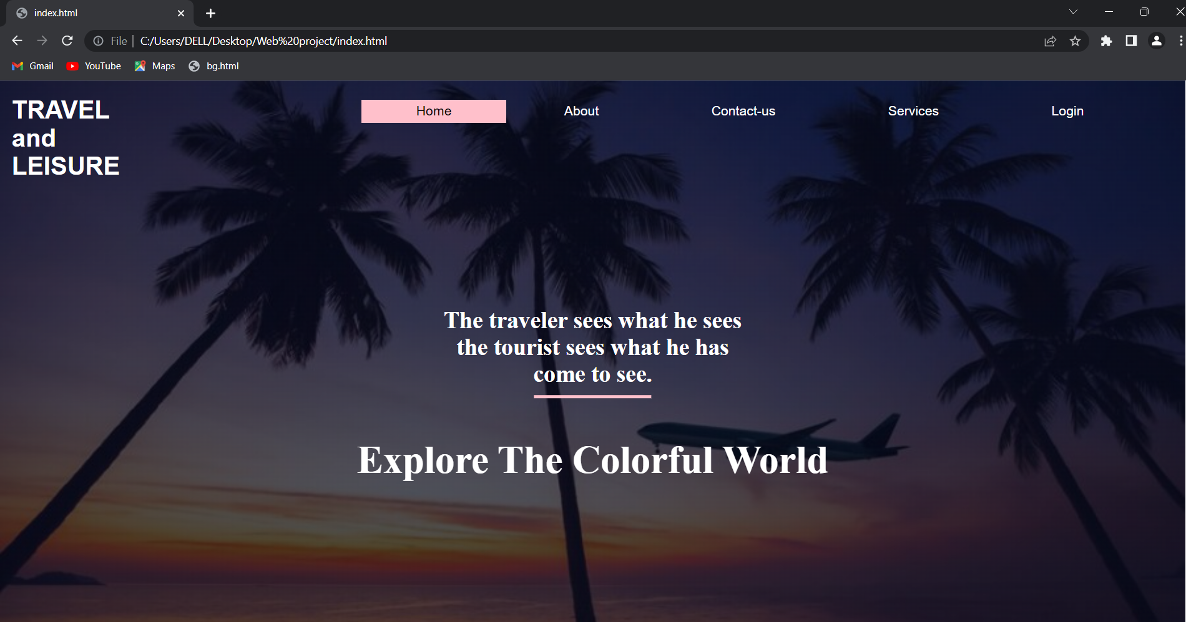

**Here when user click on book now button it will jump on another page for registration or booking which is registration.html.**

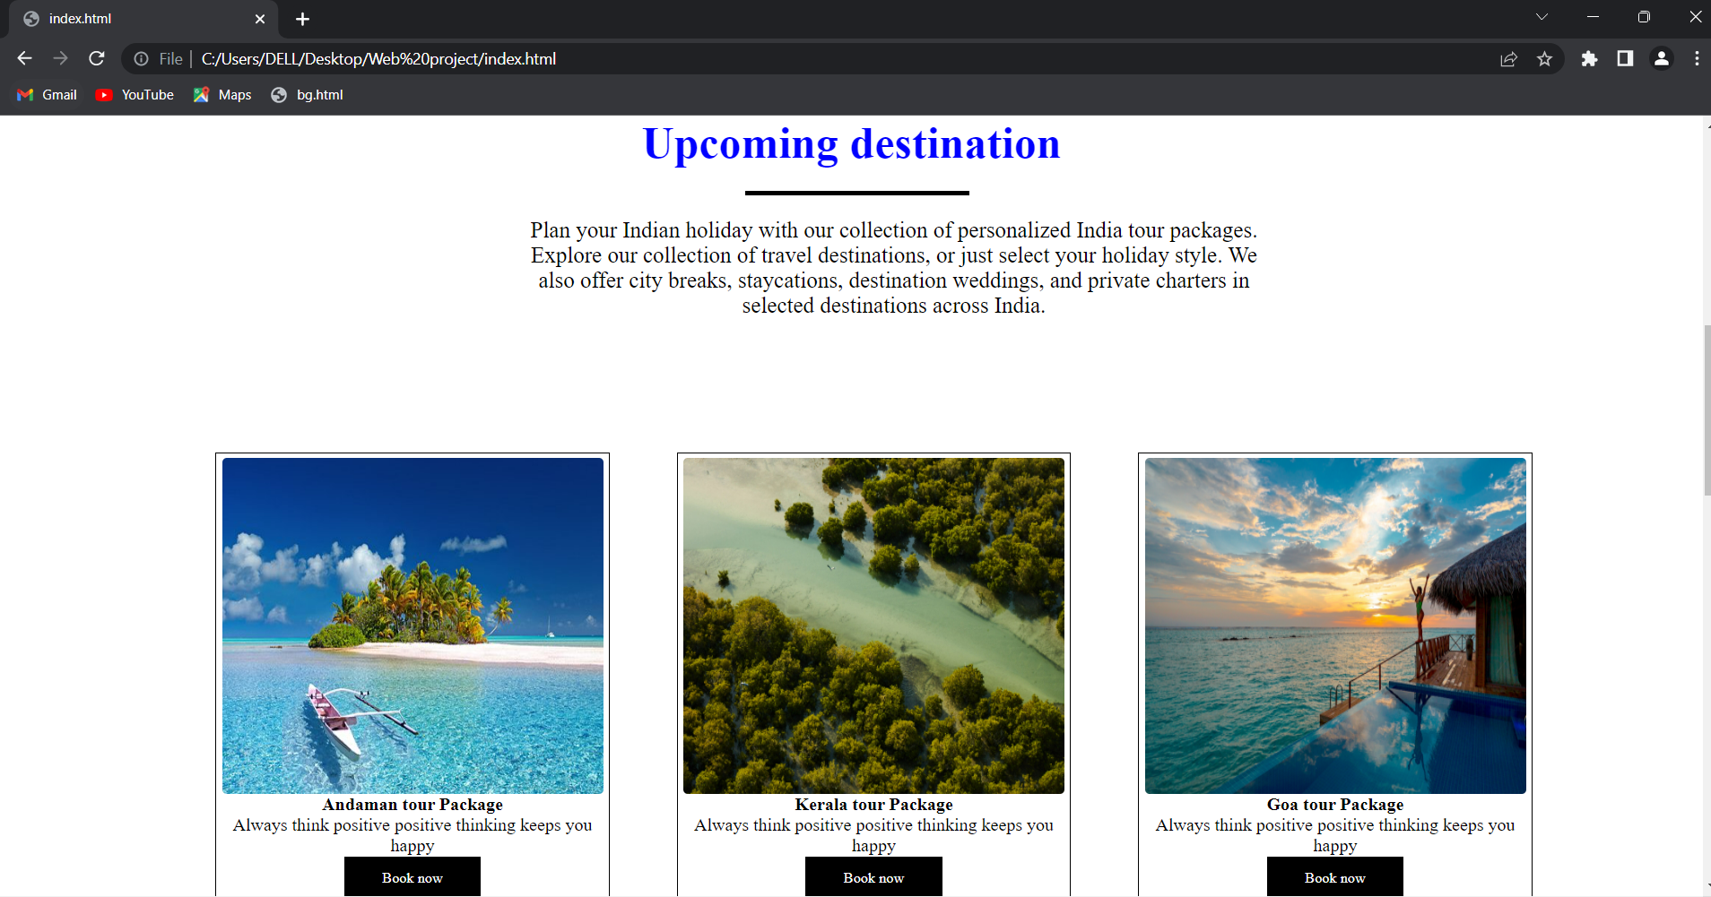

**Internal linking is used here,when user click on the about button in the navbar the page will jump on this section (#about-us) and when user will click on Read more button in this section user will jump on aboutus.html page.**

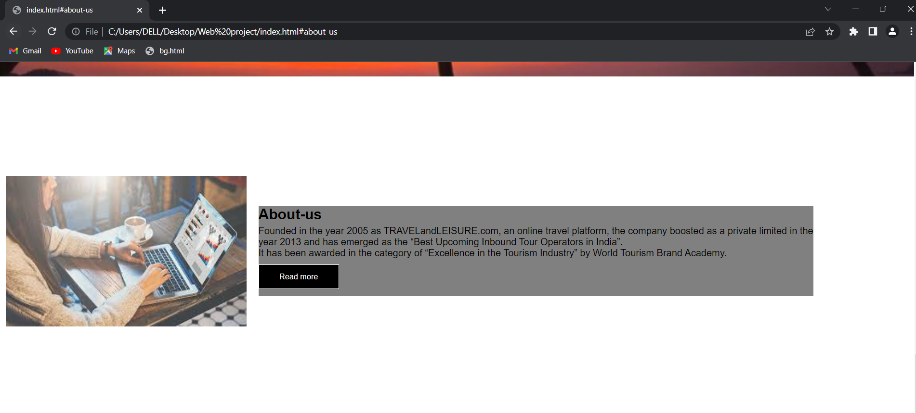

**Internal linking is used here,when user click on the services button in the navbar the page will jump on #Our_services section in the same page and when user will click on learn more button in this section user will jump on another page i.e services.html.**

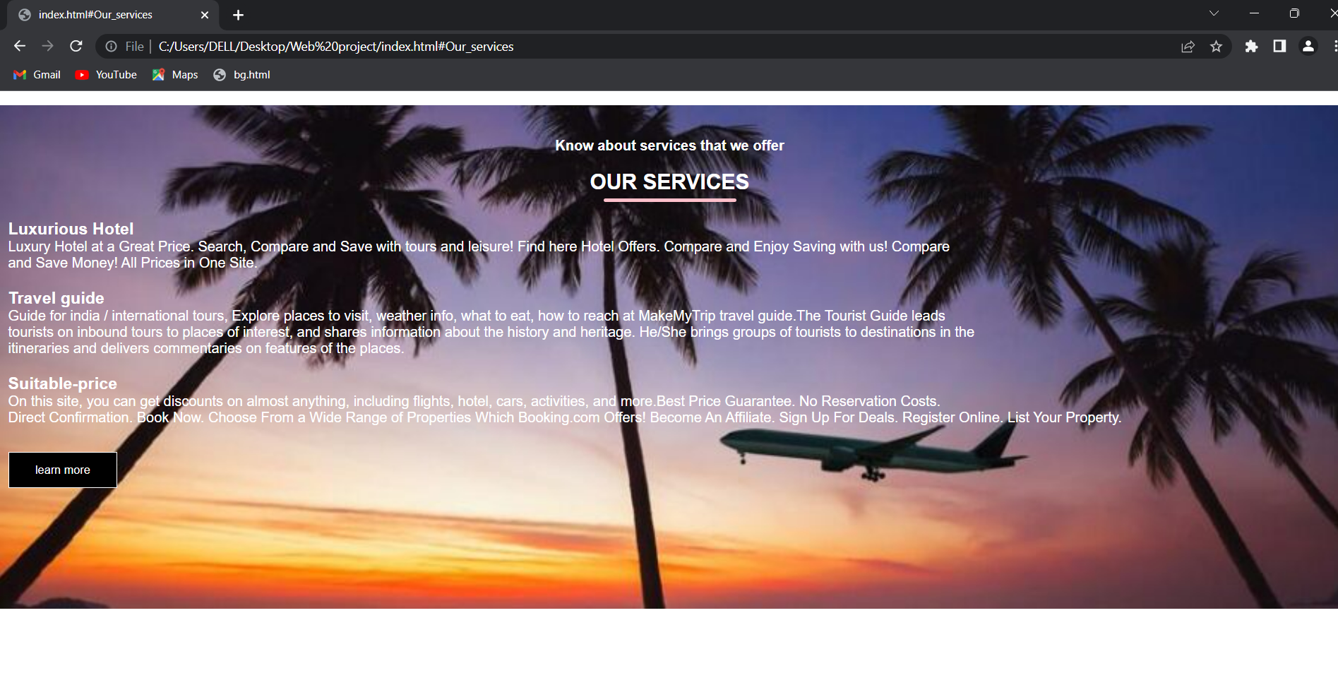

**Internal linking is used here,when user click on the Contact-us button in the navbar the page will jump on this section (#Contact-us).In which there are some quick links and Contact information about website.**

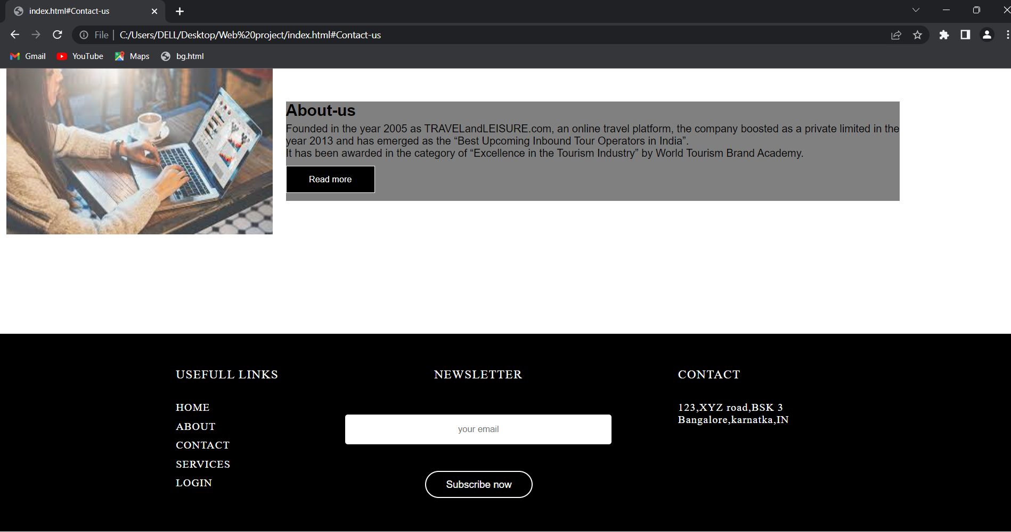

**Services.html**

**Source code:-**

<html>

<head>

<style>

section{

font-family:arial;

}

.services{

margin-top:50px;

margin-left:170px;

}

a{

text-decoration:none;

font-size:20px;

padding:8px 20px;

border:2px solid black;

border-radius:10px;

color:black;

}

.topnav{

padding:10px 20px;

margin:20px;

}

.heading{

font-family:arial;

margin-top:70px;

margin-left:170px;

margin-bottom:10px;

}

.row{

width:100%;

padding:20px;

margin:10px auto;

display:flex;

flex-direction:row;

justify-content:center;

}

.col{

margin:0 30px;

}

.col img{

border-radius:4px;

}

</style>

</head>

<body>

<div class="topnav">

<nav>

<a href="index.html">Home</a>

<a href="services.html">Services</a>

</nav>

</div>

<section>

<div class="services">

<h1>Security and Comfert</h1>

<p>We understand that security and comfort are basic to any successful travel journey. A great deal of trust on our part is invested to make your travel experience<br>

perfect and comfortable.

</p>

<h1>Advantage</h1>

<p>

With a plethora of destinations, places, and cities to visit, India is a complex country. A traveler needs to know intelligently where to go and what to see.<br>

Our comprehensive and focused India travel plans guide you to have brief overview of the most prominent tourist destinations. We also offer off-the-beaten track<br>

travel plans including India villages and give unparalleled access to Indian rural life and culture.

</p>

<h1>Special Tours</h1>

<p>

We have a list of descriptions about special Indian sites and hotspots for visitors of all ages. If you are on a lookout for other interesting Indian destinations,<br>

our in depth report on attractions, events, and accommodations make your travel smooth and convenient.<br>

One last note, please have a look at our tailor made tour plan where you can participate in deciding about your travel plan.

</p>

</div>

</section>

<div class="heading">

<h1>Guest Photo Gallery</h1>

</div>

<div class="row">

<div class="col">

<img src="service.jpg" width="300" height="300">

</div>

<div class="col">

<img src="service1.jpg" width="300" height="300">

</div>

<div class="col">

<img src="service2.jpg" width="300" height="300">

</div>

</div>

<div class="row">

<div class="col">

<img src="service3.jpg" width="300" height="300">

</div>

<div class="col">

<img src="service4.jpg" width="300" height="300">

</div>

<div class="col">

<img src="service5.jpg" width="300" height="300">

</div>

</div>

</body>

</html>

**Output:-**

**In this page there are some services which are provided by the travel company and guest photo gallery is also available in which there are some photos of their clients or guests .**

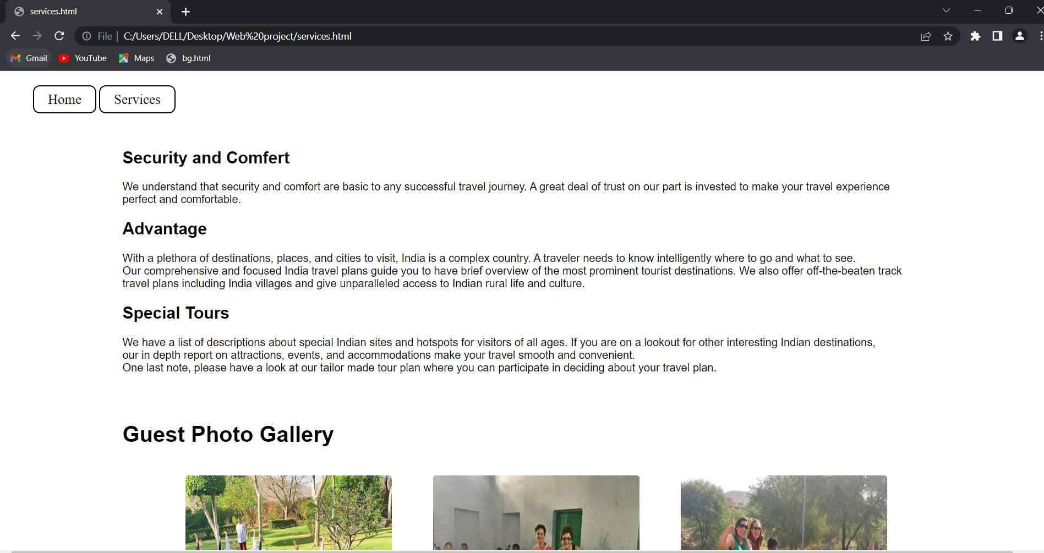

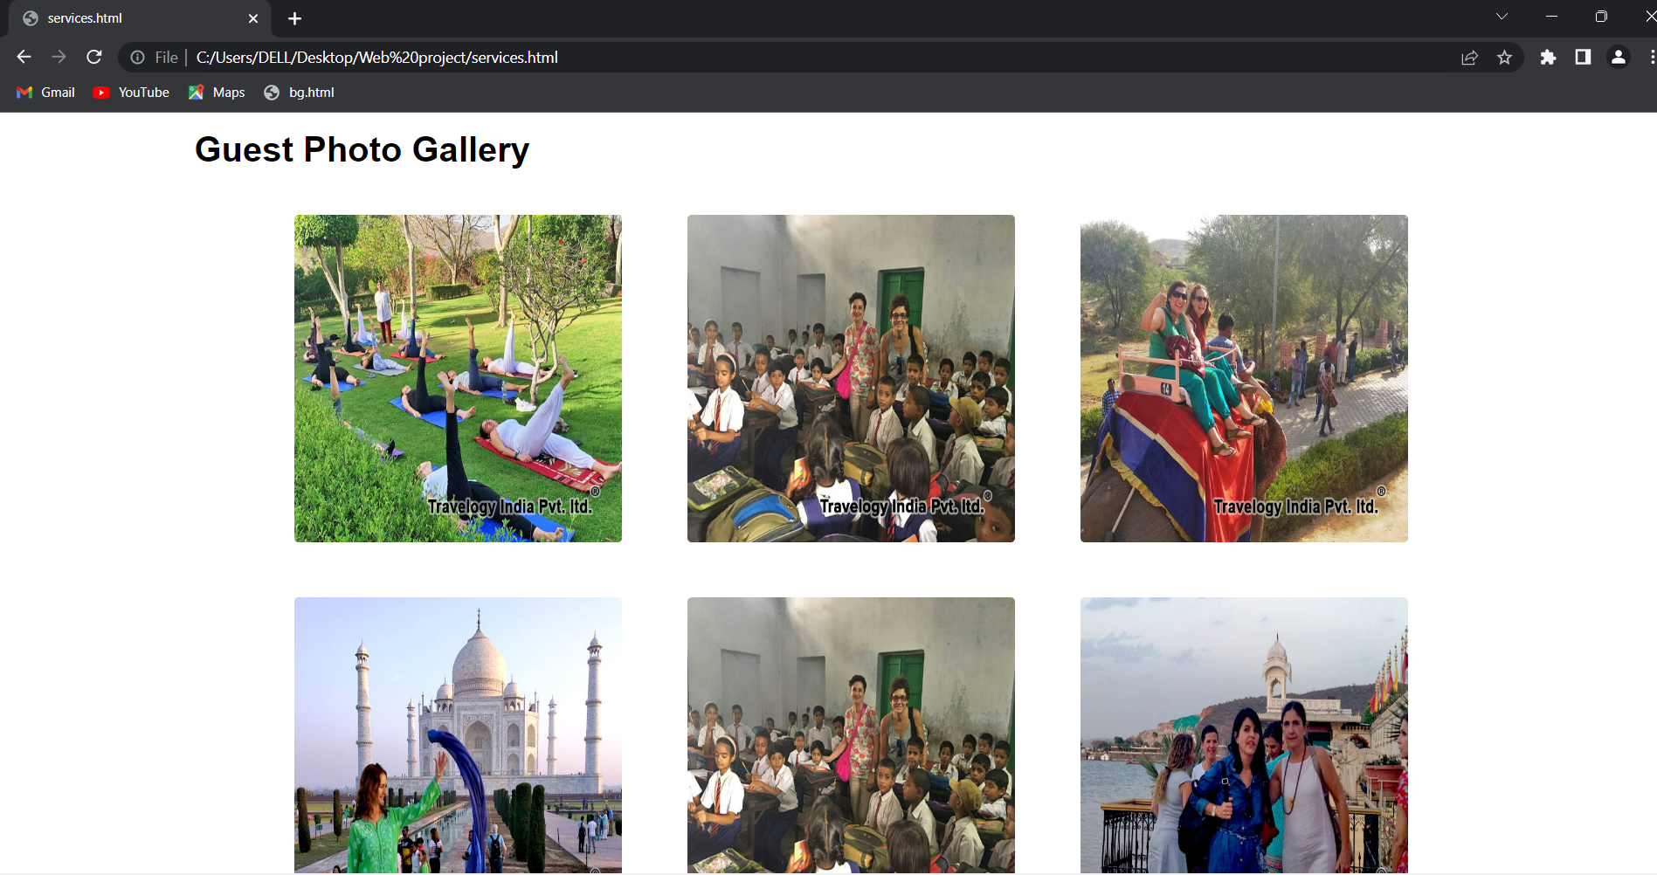

**Aboutus.html**

**Source code:-**

<html>

<head>

<style>

section{

font-family:arial;

}

.aboutus{

margin-top:20px;

margin-left:150px;

}

.mission{

background-color:gray;

margin-top:40px;

color:white;

font-size:18px;

padding-top:30px;

padding-left:150px;

padding-bottom:30px;

}

a{

text-decoration:none;

font-size:20px;

padding:8px 20px;

border:2px solid black;

border-radius:10px;

}

.topnav{

padding:10px 20px;

margin:20px;

}

</style>

<body>

<div class="topnav">

<nav>

<a href="index.html">Home</a>

<a href="aboutus.html">about</a>

</nav>

</div>

<section>

<div class="aboutus">

<h1>About Us - TRAVELandLEISURE Pvt. Ltd.</h1>

<p>TRAVELandLEISURE India, a Delhi - NCR based Tour Company, founded in 2005 dedicated

to provide inbound travel services and hospitality. Years of experience added with creative<br>

tour packages and thousands of satisfied clients have made us one of the leading tour

companies in India. Our philosophy stems from an old adage – leaving no stone <br>

unturned – which makes us reputable in Indian tour and travel circles.

</p>

<h1>At your finger tips are:</h1>

<p>Whether you know what type of trip you want, need to mix and match destinations in an itinerary, or want a specific theme based India travel, we make it easy<br>

for you to strike the best travel plan. As we have served scores of travelers coming to India from all over the world, our valuable suggestions by our experienced<br>

travel experts grace your India journey.<br><br>

<ul>

<li>Experienced travel experts with well furnished India travel plans<br><br>

<li>Theme based flexible India travel and holiday itineraries<br><br>

<li>Exclusive travel tips just right for your perennial travel needs<br><br>

<li>A wide choice of pre-package India holiday packages

</ul>

</div>

<div class="mission">

<h1>Our Mission</h1>

<p>

Whether you know what type of trip you want, need to mix and match destinations in an itinerary, or want a specific theme based India travel, we make it easy<br>

for you to strike the best travel plan. As we have served scores of travelers coming to India from all over the world, our valuable suggestions by our experienced<br>

travel experts grace your India journey.</p>

</div>

</section>

</body>

</html>

**Output:-**

**This page will give brief information about company or website.Here two buttons are provided i.e Home and about.when user click on home button the main home page will open.**

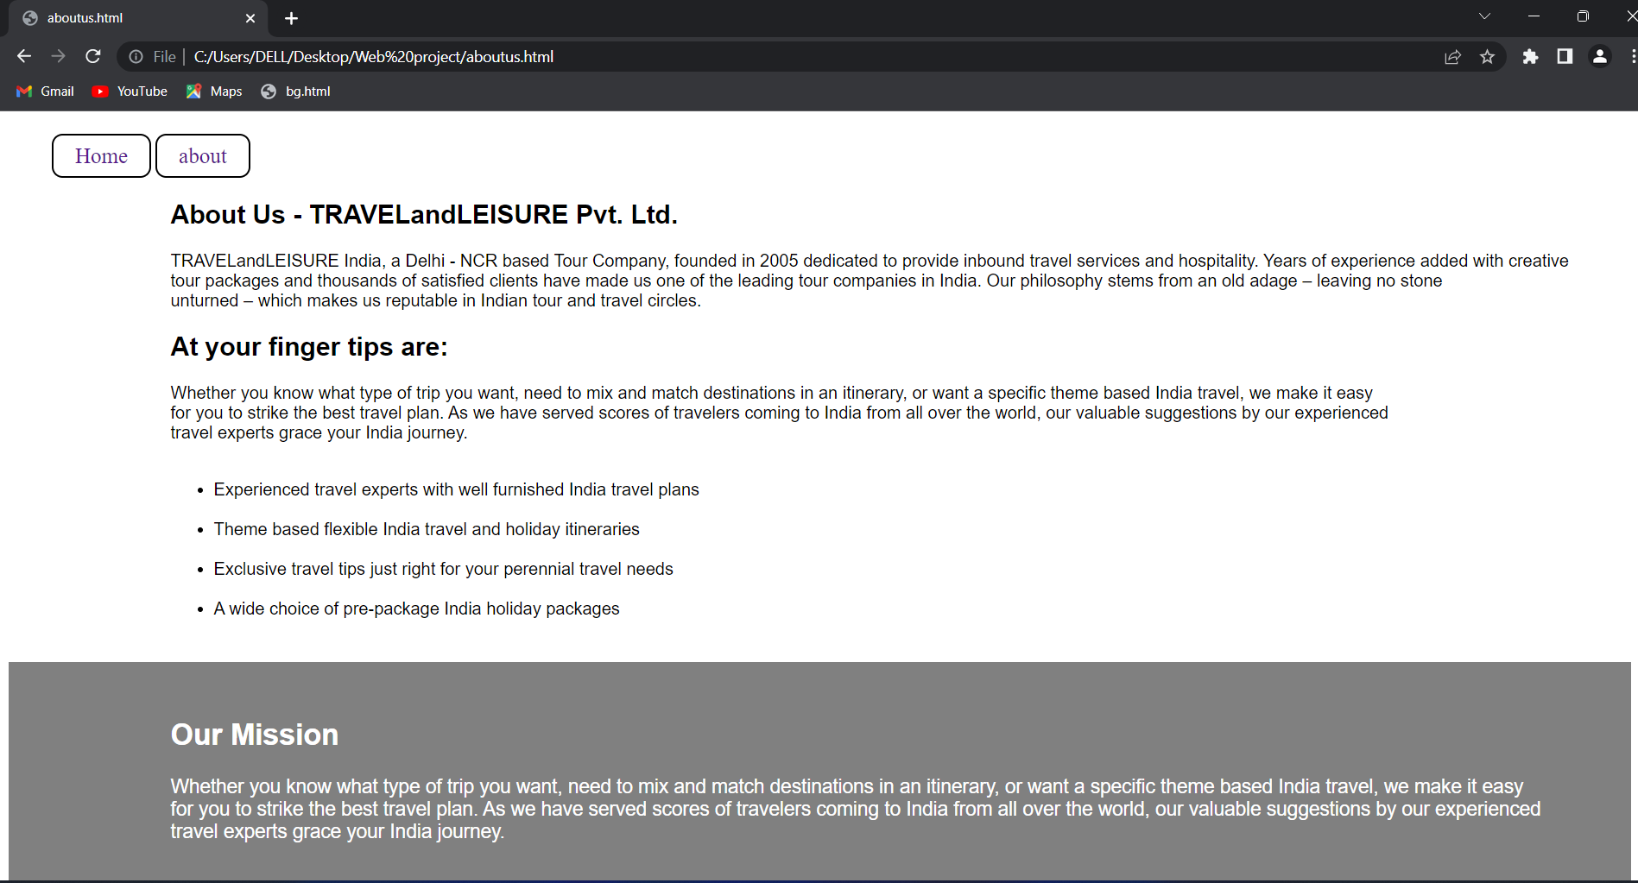

**Registration.html**

**Source code:-**

<html>

<head>

<link rel="stylesheet" type="text/css" href="style.css">

<script type="text/javascript">

function display(){

alert("Successfully Submited");

}

</script>

</head>

<body>

<section>

<div class="topnav">

<nav>

<a href="index.html">Home</a>

</nav>

</div>

<div class="main">

<h1 class="title">Registration Form</h1>

<form>

<div class="main-box">

<div class="input-box">

Full Name:

<input type="text" placeholder="please enter your" required><br><br>

</div>

<div class="input-box">

Username:

<input type="text" placeholder="please enter your" required><br><br>

</div>

<div class="input-box">

Phone Number:

<input type="Number" placeholder="Phone number" required><br><br>

</div>

<div class="input-box">

Destination:

<input type="text" placeholder="please enter destination" required><br><br>

</div>

<div class="input-box">

Email:

<input type="email" placeholder="Email" required><br><br>

</div>

<div class="input-box">

Password:

<input type="password" placeholder="Enter your password" required><br><br>

</div>

<div class="input-box">

Confirm password:

<input type="password" placeholder="confirm your password" required><br><br>

</div>

<div class="input-box">

Submit:

<input type="Submit" value="Submit" onclick="display()"><br><br>

</div>

</div>

</div>

</section>

</form>

</body>

</htm**l>**

**Style.css**

*{

padding:0;

margin:0;

}

section{

color:white;

display:flex;

justify-content:center;

height:100vh;

width:100%;

background-image:linear-gradient(rgba(4,9,30,0.7),rgba(4,9,30,0.7)),url('air.jpg');

background-size:cover;

background-position:center;

background-size:cover;

background-position;

padding:30px;

}

a{

text-decoration:none;

font-size:20px;

padding:8px 20px;

border:2px solid black;

border-radius:10px;

color:white;

}

.topnav{

margin-right:80px;

}

.main{

background:rgba(10,10,10,.35);

padding:30px 40px;

width:25%;

border-radius:1rem;

}

.title{

position:relative;

font-family:arial;

font-size:30px;

margin-bottom:10px;

}

form .main-box{

display:flex;

flex-wrap:wrap;

margin:10px 0 8px 0;

}

form .main-box .input-box input{

width:100%;

height:40px;

background:rgba(255,255,255,.1);

outline:none;

border-radius:8px;

color:white;

}

**Output:-**

**When user click on login button in navbar of home page this page will open for registration.**

